**Database Design Coursework**

Student Name: Samuel Horry

Student ID: Samuel.Horry

Student Number: 240004289

**Scenario Topic Name**: Tech Repair Shop

**Scenario**:

The Custom Computer Company diagnoses and repairs desktops, laptops and other computer peripherals. Employees are either technicians or administrative staff, with technicians specialising in hardware, software or both. Employees have a unique ID, email and hire date. Customers provide their email, phone number and name, and may own multiple devices. Devices include desktops, laptops and peripherals, each identified by a device ID, type, operating system and hardware specifications. Peripherals can include monitors and printers. Each device has a support ticket that contains information on problem notes, status and priority level. A support problem can be taken on by multiple technicians at a time, but each technician can only work on one problem at a time with some repairs requiring special equipment. Customers can be either individuals or businesses.

**Example queries**

* What is this customer’s phone number?
* What operating system is this device running?
* Is this customer an individual or a business?
* What is the priority level of this support ticket?
* When was this employee hired?

**Entity Relationship Model**

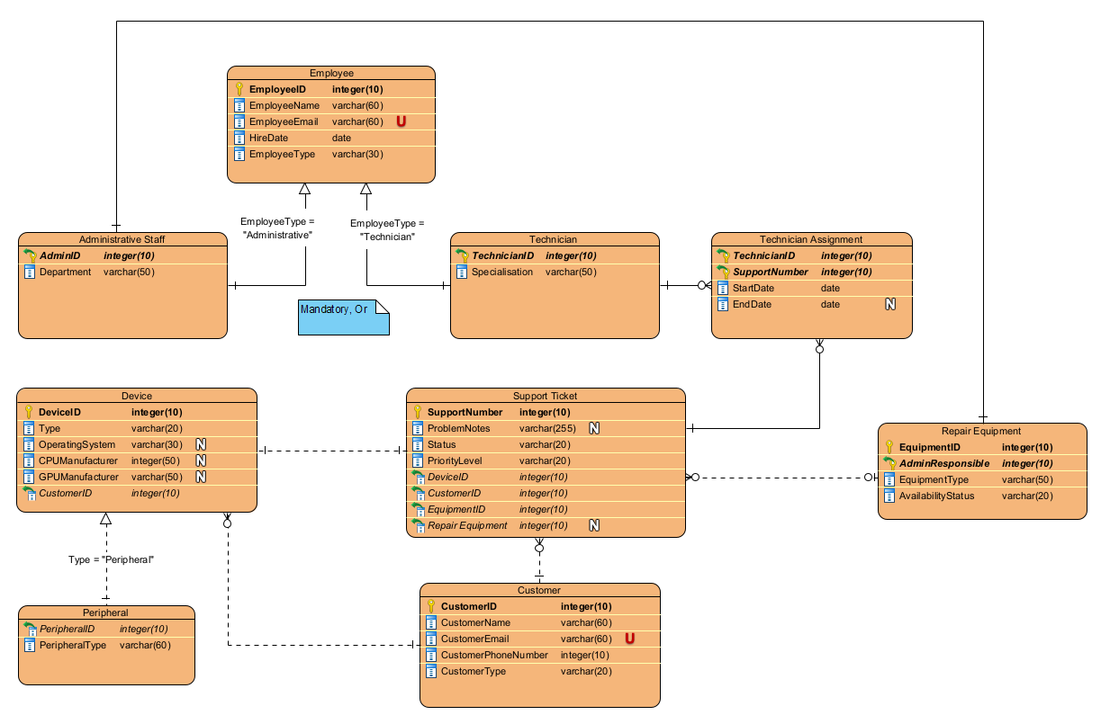

**Relational Model Tables**

* Copy and paste the table below for as many relational tables as you need
* Replace the placeholder names (table-name1, attribute-name5 etc) with the table and attribute names you derived from your ER model
* List primary key attributes first
* Add new rows to the tables (in the correct place) as needed
* Delete any unnecessary rows (attribute rows and foreign key rows if not used)
* Primary keys are to be specified in the format PRIMARY KEY (attribute-name1, attribute-name2, etc)
* Foreign keys are to be specified in the format ‘FOREIGN KEY (attribute-name) REFERENCES table-name (attribute-name)

|  |  |
| --- | --- |
| **Relational table specification** | **Marker’s corrections (Do not write in this column)** |
| **Table name:** table-name1 |  |
| **Attributes** |  |
| attribute-name1 |  |
| attribute-name2 |  |
| attribute-name3 |  |
| attribute-name4 |  |
| etc |  |
| **PRIMARY KEY** (attribute-name1, attribute-name2, etc) |  |
| **FOREIGN KEY** (attribute-name3) REFERENCES table-name2 (attribute-name67) |  |
| **FOREIGN KEY** (attribute-name4) REFERENCES table-name5 (attribute-name129) |  |
| etc |  |

Insert additional tables here……..

**Marker’s Comments** (Do not write in this section)

**Important:** Please note that marker’s corrections to your relational tables are there to help you construct a working database for the second coursework. They are not the determinant of your mark. For more information on how your work is assessed see the coursework specification and grade related criteria.

**Coursework Mark** (100 marks available):